

Functional Process - User Stories & Wireframes

Contents
User Stories- Functional Process 3
1. Check Functional Status 3
1.1 Mock-ups 4
2. Mark property functional / not functional 6
2.1 Mock-ups 7
3. View Request- Department User 11
3.1 Mock-ups 12
4. User Story- Request Functional Approval 18
4.1 Mock-ups 19
5. View Request- Approver 20
5.1 Mock-ups 21
6. User Story- Approve/Reject Functional approval Request 25
6.1 Mock-ups 26
7. Resubmit request for Functional Approval 28
7.1 Mock-ups 29
8. Cancel Functional Approval request 30
8.1 Mock-ups 31
9. View Comment 32
9.1 Mock-ups 33
10. Generate Functional Certificate 34
10.1 Mock-ups 35
11. Generate Functional Charge challan 36
11.1 Mock-ups 37
12. SMS/Email Notifications to allottee 39

Changes

S NO | MODULE | DESCRIPTION | Date
1 | All | Updated Mockups | 27/06/20116
2 | 1,2,5,6 | Acceptance criteria updated | 27/06/20116
3 | 9,10 | Save button renamed to Download button | 27/06/20116

User Stories- Functional Process

User Story- Request Functional Approval

Sprint | 6
User Story ID | 004
User Story Title | Request Functional Approval
Actors | Department user
Story | As a department user, I want to request for approval of a functional property, so that I can generate Functional certificate.
Pre Conditions | - User should have required access rights.
Business Criteria | - Functional request would be submitted for completed properties only (properties, to which completion certificate has been issued. Alternatively, properties which are marked completed or partially completed)  - User would only be able submit functional request for his department.  - In case of property is transferred, its previous functional status would be null and void and a re-functional approval is required.  - Once, the request is submitted a notification would be sent to approver for the same.  - Auto notifications will be sent to approver with an interval of 3 days, if a request is in progress for approval for more than 3 days.  - If a request is submitted to an approver but not actioned its status would be ‘pending’. Approved and rejected requests would have ‘approved’ and ‘rejected’ status respectively.  - If the request is cancelled by the department user, its status would be ‘cancelled’.
Acceptance Criteria | Navigation-> Manage Functional Properties -> Request functional  - User would get a form which contain following fields:  - RID: drop down  - Based on this selection the following information would be displayed:  - Property No.  - Scheme Name  - Department  - Applicant Name  - Gender  - Father/Husband Name  - Property type  - Area  - Floor (in case of flats)  - Functional Due Date ( to be filled)  - User would enter the Functional due date.  - User would check the documents submitted (checkbox).  - Meter sealing certificate by UPSEB  - Affidavit  - Registration Certificate of trade tax dept.  - NDC from Accounts  - Once, user validates the information he would submit request for by clicking on ‘Submit Request’ button.  - User would be given an option to choose the approver. User would select the approver name from the drop down and click ‘Submit’ button to submit the request.  - Alternatively, user would click on ‘back’ button to return to manage functional menu without making any changes.  - After successful submission of request it would be displayed in a grid on manage functional properties page with following columns:  - Request No  - RID  - Property No  - Request date  - Approved date (for approved entries)  - Status (Pending, cancelled, approved, rejected)
Field level Validation

Mock-ups
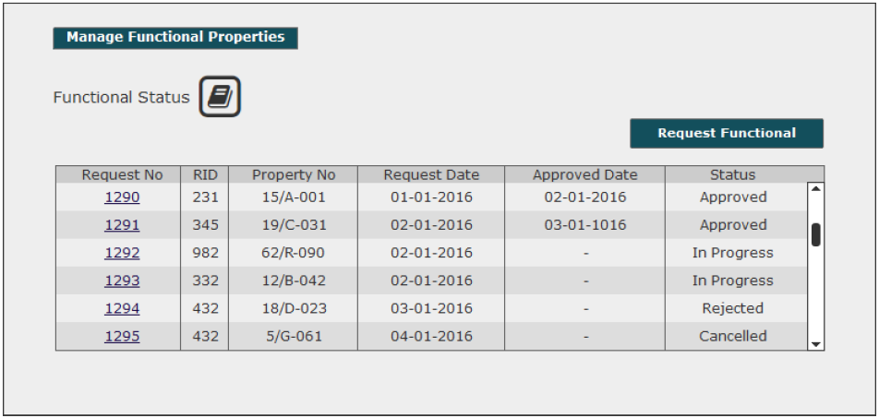
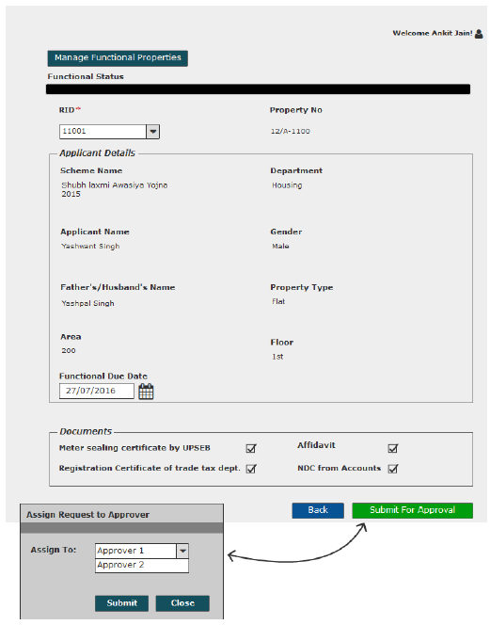

View Request- Department User

Sprint | 4
User Story ID | 003
User Story Title | View Request
Actors | Department User
Story | As a department user, I want to view submitted functional request of a property.
Pre Conditions | - User should have required access rights.
Business Criteria | - If request is submitted but not actioned by the approver then user would get ‘Cancel Request’ and ‘back’ button.  - If the request is rejected by the approver then user would get the option of ‘Resubmit Request’ and ‘View Comment’ along with ‘ack’ button  - For cancelled requests user would get the option to ‘resubmit Request’ and ‘Back’ button.  - If request is approved by the approver then user would get following options:  - Functional Charge Challan  - Generate Functional Certificate  - View Comment  - Back
Acceptance Criteria | - User would click on a particular request no from the grid under manage functional properties menu  - User would get a screen which would display the following information:  - RID  - Scheme Name  - Department  - Property No  - Applicant Name  - Father/Husband Name  - Property type  - Area  - Floor (In case of Housing properties)  - Functional due date  - Functional date (for approved entry)  - User would get documents details.  - User would get different options based on the scenario( see Business Rules)
Field level Validation

Mock-ups

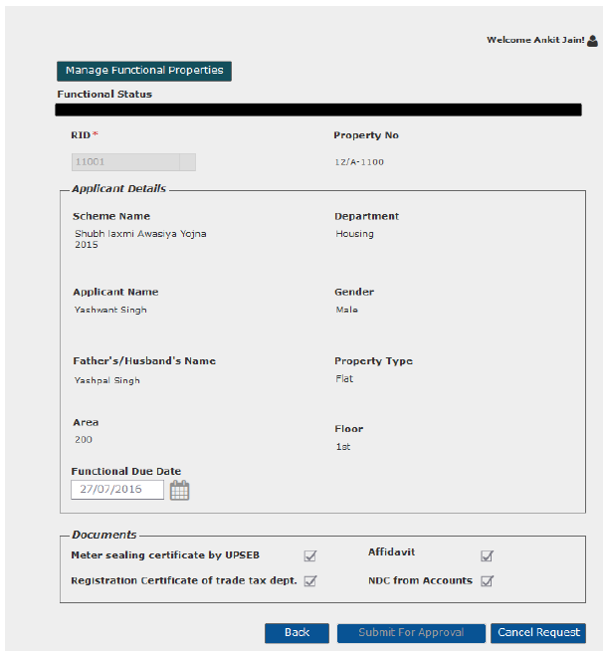
Request submitted for approval
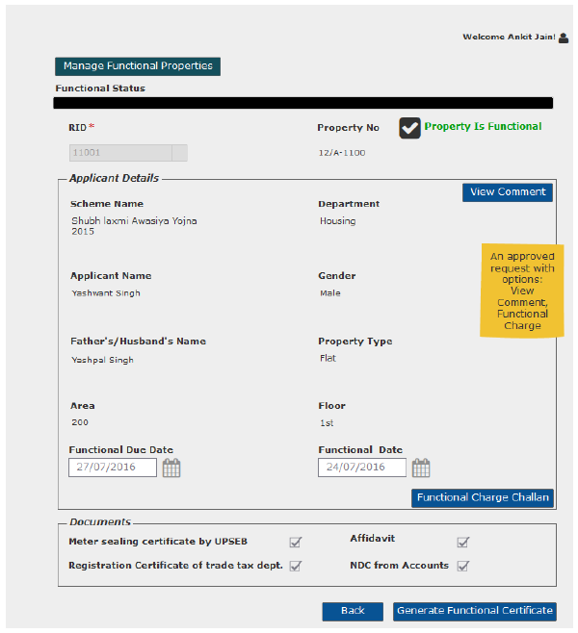
Approved Functional Request
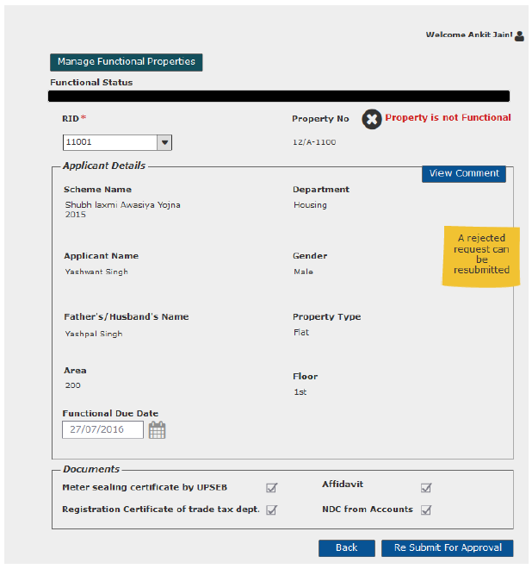
Rejected Functional request

Cancel Functional Approval request

Sprint | 6
User Story ID | 008
User Story Title | Cancel functional approval request
Actors | Department User
Story | As a department user, I want to cancel functional approval request of a property.
Pre Conditions | - User should have required access rights.
Business Criteria | - Only those request which are in progress would be cancelled.
Acceptance Criteria | - User would click on a particular request from the grid under manage functional properties menu.  - Request will be displayed and user would click on the ‘Cancel Request’ button to cancel the request.  - Alternatively, user would click on ‘Back’ button to return to the manage Functional page without making any changes.
Field level Validation

Mock-ups

View Comment- Department User

Sprint | 6
User Story ID | 009
User Story Title | View Comment
Actors | Department user
Story | As a department user, I want to view comment on functional request
Pre Conditions | - User should have required access rights.
Business Criteria | - Only, approved/rejected request would contain the option to View comment.
Acceptance Criteria | Navigation: Manage Functional Properties -> Functional Request -> View Comment  - User would click on ‘View Comment’ button on functional request screen.  - User would see a Popup window with the following information:  - Comment from  - Comment  - Comment Date  - If user needs to go back or cancel this screen, user would click on ‘Close’ button and the control will be directed to Functional order request screen.
Field Level Validation

Mock-ups
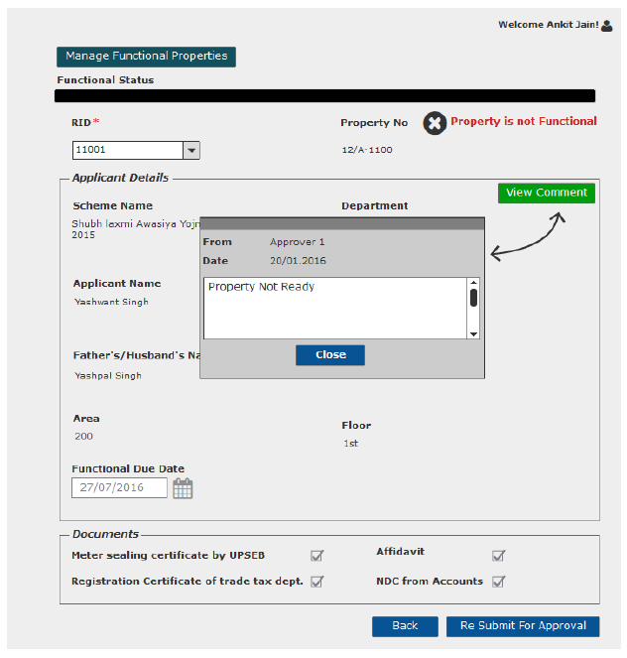

View Request- Approver

Sprint | 6
User Story ID | 005
User Story Title | View Request
Actors | Approver
Story | As an approver, I want to view submitted functional approval request of a property.
Pre Conditions | - User should have required access rights.
Business Criteria | - If the request is not actioned then, user would get ‘Approve’ and ‘Reject’ button along with ‘back’ button.  - If request is cancelled then, user would get ‘back’ button.  - If request is approved then, user would get ‘View Comment’ and ‘back’ button.  - If request is rejected then, user would get ‘View comment’, ‘Approve’ and ‘back’ button.
Acceptance Criteria | - User would click on ‘Functional Request’ under ‘Manage request’ menu and get a grid which contain functional requests information with following columns:  - Request No  - RID  - Property No  - Request Date  - Approved Date  - Status (Pending/Approved/Rejected/Cancelled)  - User would click on a particular request from the grid under Manage Request menu  - User would get a screen which would display the following information:  - Property Functional Status  - RID  - Scheme Name  - Department  - Property No  - Applicant Name  - Father/Husband Name  - Property type  - Area  - Floor (In case of flats)  - Functional due date  - Functional date (for approved entries)  - User would get documents detail.  - User would get different options based on the scenario( see Business Rules)
Field level Validation

Mock-ups

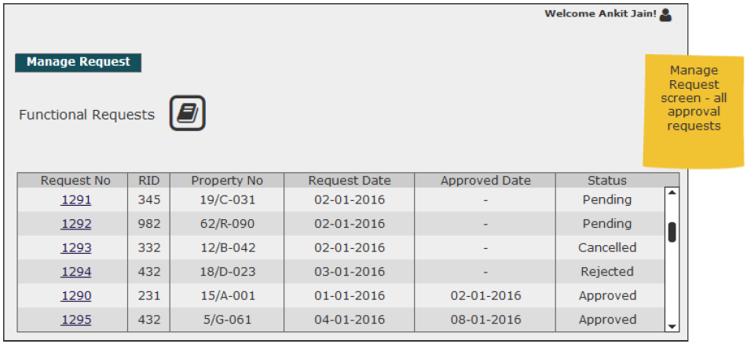
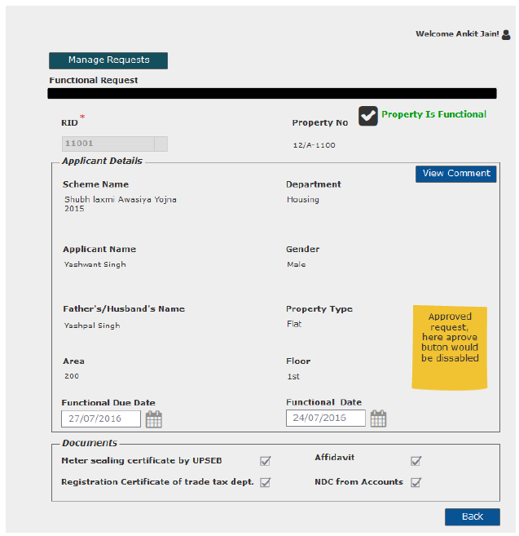
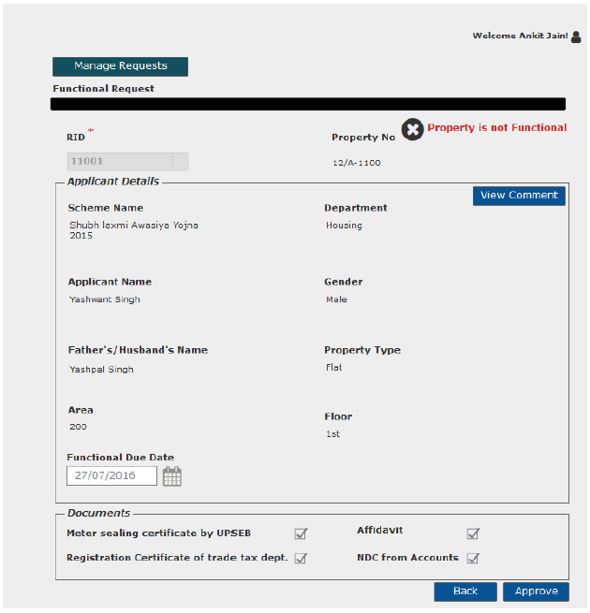

User Story- Approve/Reject Functional approval Request

Sprint | 6
User Story ID | 006
User Story Title | Approve/Reject Functional Approval request
Actors | Approver
Story | As an approver, I want to action functional request of a property so that I can Approve/Reject request.
Pre Conditions | - User should have required access rights.
Business Criteria | - Once a request is approved/rejected a notification would be send to initiator of the request.  - Once the request is approved property is marked functional, approval date is functional date.  - It is mandatory to provide a comment for rejecting a request.  - Rejected request can be approved again.  - It is mandatory to provide a comment when approving an already rejected request.  - If a request is not actioned its status would be ‘pending’. Approved and rejected requests would have ‘approved’ and ‘rejected’ status respectively.  - If the request is cancelled by the department user, its status would be ‘cancelled’. Approver would not get any options to approve, reject or change area for these requests.  - Requests with ‘Pending’ as Status column would always be displayed on top.
Acceptance Criteria | - User would click on ‘Functional Request’ under ‘Manage request’ menu and get a grid which contain functional requests information with following columns:  - Request No  - RID  - Property No  - Request Date  - Approved Date  - Status (Pending/Approved/Rejected/Cancelled)  - User would click on a particular request from the grid under Manage Request menu  - User would get a screen which would display the following information:  - Property Functional Status  - RID  - Scheme Name  - Department  - Property No  - Applicant Name  - Father/Husband Name  - Property type  - Area  - Floor (In case of flats)  - Functional Due Date  - User would get documents detail which are submitted by allottee.  - Meter sealing certificate by UPSEB  - Affidavit  - Registration Certificate of trade tax dept.  - NDC from Accounts  - Under User would click on ‘Approve’ button to approve the request or ‘Reject’ button to reject the request.  - In both cases user would get a popup window to provide comment.  - In case of ‘Approve’ user would have a choice to provide comment or not however, in case of ‘Reject’ it is mandatory to provide comment.
Field level Validation | - Comment: Text, maximum 500 characters, mandatory in case of reject list.

Mock-ups

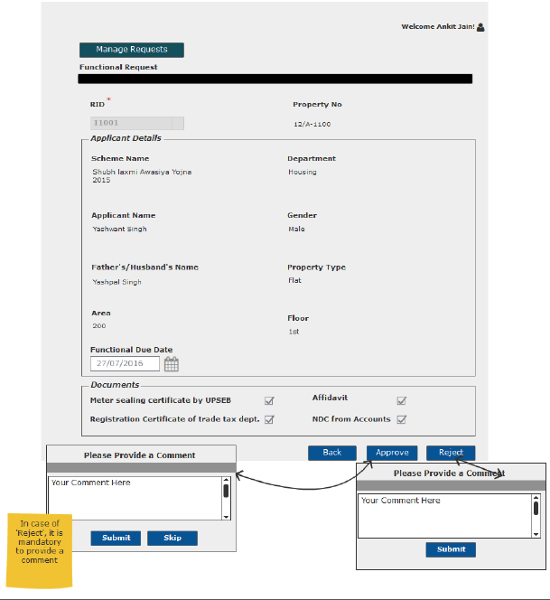

Resubmit request for Functional Approval

Sprint | 6
User Story ID | 007
User Story Title | Resubmit request for Functional Approval
Actors | Department User
Story | As a department user, I want to resubmit functional approval request of a property.
Pre Conditions | - User should have required access rights.
Business Criteria | - Only Cancelled and rejected requests would be resubmitted.  - Requested date would be updated on the grid.
Acceptance Criteria | - User would click on a particular request from the grid under ‘Manage Functional Properties’ menu.  - Request will be displayed and user would click on the ‘Resubmit for Approval’ button to request again.  - Alternatively, user would click on ‘Back’ button to return to the manage Functional page without making any changes.
Field level Validation

Mock-ups
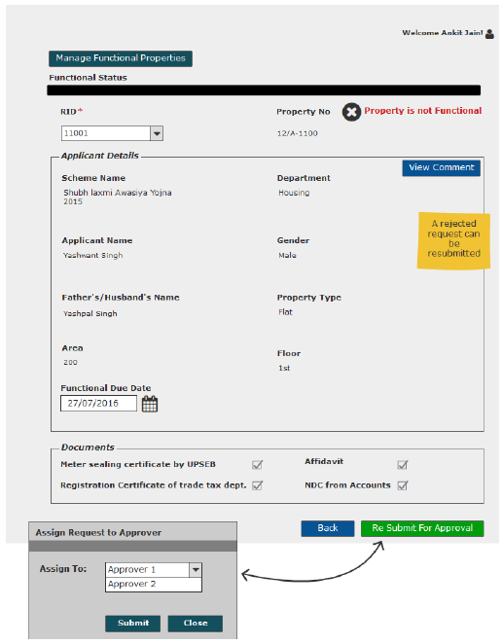

View Comment- Approver

Sprint | 6
User Story ID | 009
User Story Title | View Comment
Actors | Department user
Story | As a department user, I want to view comment on functional request
Pre Conditions | - User should have required access rights.
Business Criteria | - Only, approved/rejected request would contain the option to View comment.
Acceptance Criteria | Navigation: Manage Request -> Functional Request -> View Comment  - User would click on ‘View Comment’ button on functional request screen.  - User would see a Popup window with the following information:  - Comment from  - Comment  - Comment Date  - If user needs to go back or cancel this screen, user would click on ‘Close’ button and the control will be directed to Functional order request screen.
Field Level Validation

Mock-ups

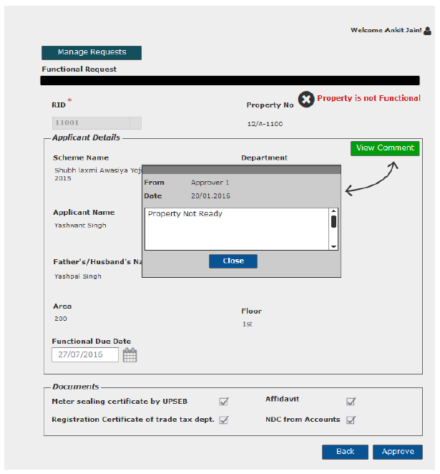

Generate Functional Certificate

Sprint | 6
User Story ID | 010
User Story Title | Generate Functional Certificate
Actors | Department user
Story | As a department user, I want to generate functional Certificate
Pre Conditions | - User should have required access rights.
Business Criteria | - Only, approved request would contain the option to generate functional certificate.  - System would check for payment of functional charge, If not payed then, functional certificate will not be generated.
Acceptance Criteria | - User would click on ‘Generate Functional Certificate’ button on functional request screen.  - Functional certificate would be displayed on a separate screen.  - User would have the options to save the file to his local system by clicking on ‘download’ button or print functional Certificate by clicking on ‘Print’ button.
Field Level Validations

Mock-ups
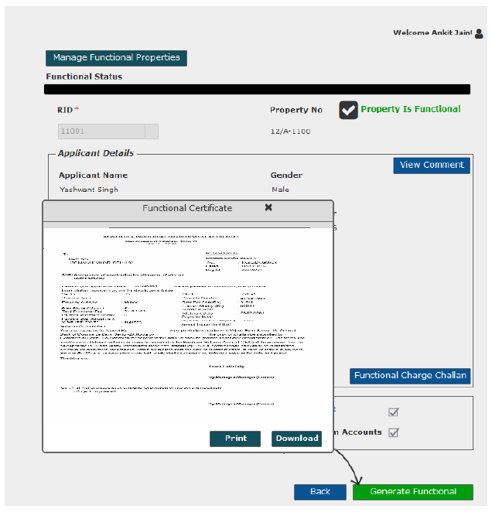

Generate Functional Charge challan

Sprint | 6
User Story ID | 011
User Story Title | Generate Functional Charge Challan
Actors | Department user
Story | As a department user, I want to generate payment challan for functional charge.
Pre Conditions | - User should have required access rights.
Business Criteria | - Only approved functional properties would contain the option to generate payment challan for functional charge.  - Payment Challan would be generated only if there are no dues till date.
Acceptance Criteria | - User would click on ‘Functional Charge Challan’ button on functional request screen.  - Challan would be displayed on a separate screen.  - User would have the options to save the file to his local system by clicking on ‘download’ button or print challan by clicking on ‘Print’ button.
Field Level Validations

Mock-ups

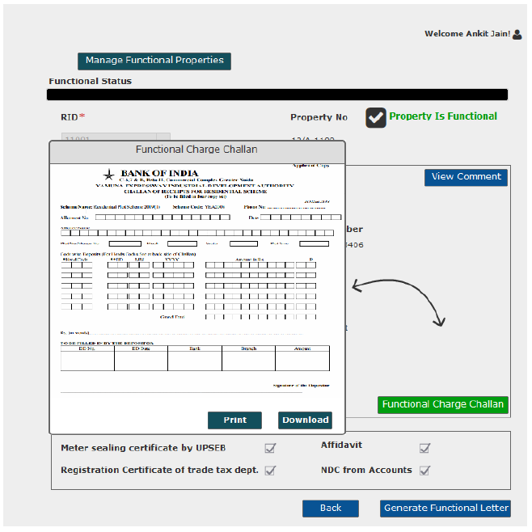

SMS/Email Notifications to allottee

Sprint | 6
User Story ID | 012
User Story Title | SMS/Email notifications to allottee
Actors | allottee
Story | As an allottee I want system to send me SMS/email notifications for Functional request
Pre Conditions | - User should have required access rights.
Business Criteria | - An SMS/Email notification would be send to allottee once, the request is submitted for Functional Status.  - An SMS/Email notification, in case of property status not functional.  - An SMS/Email notification, in case of property status functional:  - An SMS/Email notification would be send to allottee, if the request is cancelled.  - An SMS/Email notification would be send to allottee, if the request is rejected with comment.  - An SMS/Email notification would be send to allottee, if the request is approved, asking user to clear any dues in order to get functional letter and to pay functional charge.  - Once functional charge is paid, notification to user to get his functional Certificate
Acceptance Criteria
Field Level Validations

